Progress Report 6
Student: Aimé Emmanuel Sabiraguha
Chinese Name: 阿莫
Date: May 10, 2026
Supervisor: Wang HongBing
TIME SERIES FORECASTING
1. Executive Summary
This report summarizes my progress in time series forecasting research. I have tried to set up the Time Series Library (TSLib), conducted experiments on multiple datasets (ETTh1, ETTh2, ETTm1), evaluated five different deep learning models, and collected comprehensive results using MSE and MAE metrics.
2. Work Completed
  - Environment Setup
- Installed TSLib from GitHub (thuml/Time-Series-Library)
- Configured Python 3.13 environment with all dependencies
- Installed PyTorch (CPU version) and required packages

2.2 Models Tested
Model | Architecture | Description
DLinear | MLP-based | Simple linear model with decomposition
SegRNN | RNN-based | Segment Recurrent Neural Network
iTransformer | Transformer (series-wise) | Inverted Transformer
PatchTST | Transformer (patch-wise) | Patching Transformer
Crossformer | Transformer (cross-dim) | Cross-dimension attention

2.3 Datasets Used
Dataset | Frequency | Samples | Variables
ETTh1 | Hourly | 17,420 | 7
ETTh2 | Hourly | 17,420 | 7
ETTm1 | 15 minutes | 69,680 | 7

2.4 Experiment Settings
- Input length (seq_len): 96
- Prediction length (pred_len): 96
- Training epochs: 10 with early stopping
- Loss function: MSE
- Device: CPU
3. Results
3.1 Model Comparison on ETTh1 (96→96)
Rank | Model | MSE | MAE
1 | SegRNN | 0.3801 | 0.4055
2 | iTransformer | 0.3857 | 0.4036
3 | PatchTST | 0.3898 | 0.4084
4 | Crossformer | 0.4113 | 0.4301
5 | DLinear | 0.4356 | 0.4402
SegRNN (RNN-based) outperformed all Transformer models on ETTh1.

3.2 DLinear Performance Across Different Prediction Lengths (ETTh1)
Prediction Length | MSE | MAE
96 | 0.4356 | 0.4402
192 | 0.4450 | 0.4404
336 | 0.4874 | 0.4654
720 | 0.5126 | 0.5104
As prediction length increases, forecasting error increases (expected behavior).
3.3 SegRNN Performance Across Different Datasets (96→96)
Dataset | MSE | MAE
ETTh2 | 0.2891 | 0.3450
ETTm1 | 0.3271 | 0.3663
ETTh1 | 0.3801 | 0.4055
ETTh2 is significantly easier to predict than ETTh1 (24% lower MSE).

3.4 Model Comparison on ETTh2 (96→96)
Model | MSE | MAE
SegRNN | 0.2891 | 0.3450
iTransformer | 0.2938 | 0.3450
PatchTST | 0.2983 | 0.3505
SegRNN remains the best performer on ETTh2. All models perform ~24% better on ETTh2 than ETTh1.
4. Visualizations
Figure 1: Model Performance Comparison (ETTh1 vs ETTh2)

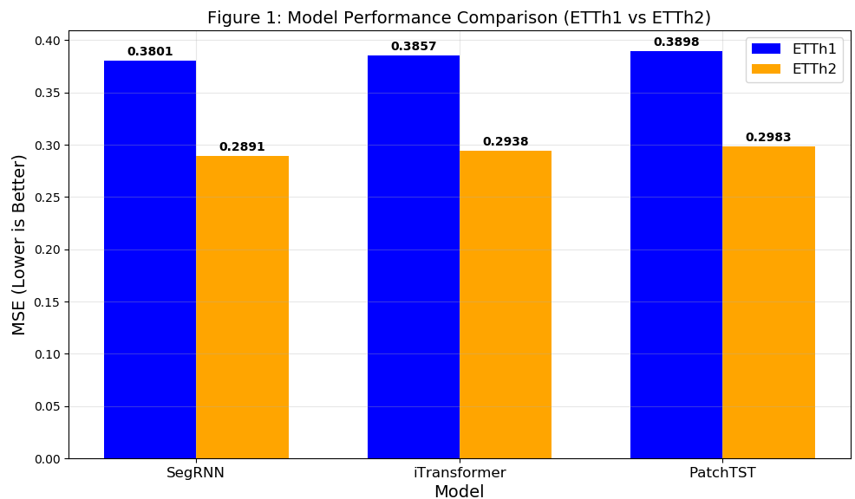
Interpretation: Lower MSE values indicate better forecasting accuracy. All three models achieve approximately 24% lower MSE on ETTh2 compared to ETTh1, suggesting that ETTh2 has more predictable patterns. SegRNN consistently outperforms the Transformer-based models on both datasets.
Figure 2: PowerShell Results Output

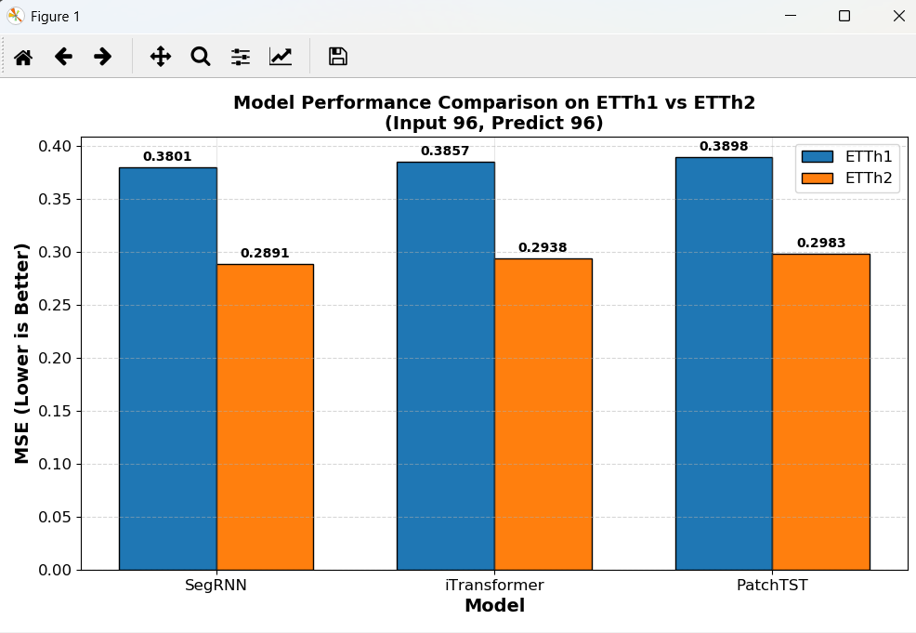
Figure 3: GitHub Repository
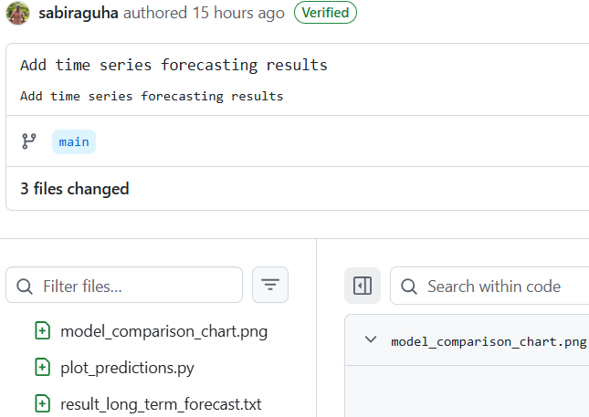
All code and results uploaded to: Add time series forecasting results · sabiraguha/my-python-scripts@5284ed2

